You are receiving this email as a member of the media.
If you wish to unsubscribe from future messages, please reply with UNSUBSCRIBE in the subject line.

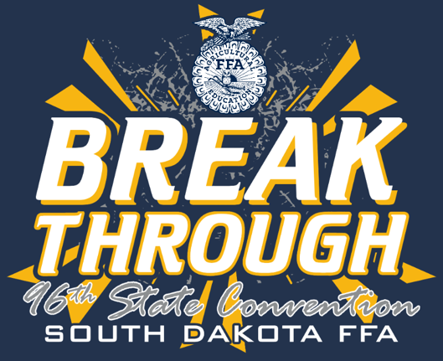
NEWS RELEASE

Website: www.sdaged.org
Facebook: www.facebook.com/South.Dakota.FFA
Instagram: @sdffaassociation
For more information, contact:
Caroline Hansen
South Dakota Leadership and Program Manager
Caroline.hansen@sdaged.org
South Dakota FFA Association

FOR IMMEDIATE RELEASE
April 22, 2024
State Officer photos available to download at: https://drive.google.com/file/d/1Fmqd-YR9NfNku8dLYCcIF1zQKKt_wrJ0/view?usp=sharing

South Dakota FFA Elects State Officers at Convention

BROOKINGS, South Dakota – Six South Dakota FFA members were elected to serve as the 2024-2025 South Dakota FFA Officer team at the 96th South Dakota FFA Convention, April 18-20, 2024. As state officers, they will represent more than 6,437 South Dakota FFA members.
The 2024-2025 South Dakota FFA Officer team includes: President Maya Howard, Miller; Vice President Raul Berrones, Milbank; Secretary Ethan Hendrix, Rapid City Stevens; Treasurer Bailey Weegar, Viborg-Hurley; Reporter Hailey Kizer, Howard; and Sentinel Ben Storm, Sturgis.
The state FFA officer team will travel across the state sharing their passion for agriculture, leadership, and service. South Dakota FFA officers present workshops and conferences across the state and challenge FFA members to serve their communities and the agriculture industry. State Officers advocate for the agriculture industry at various events including South Dakota FFA State Fair at the Ag Adventure Center as well as serve as delegates to the National FFA Convention this fall.
Sponsors of the State Officer Team Trainings, Official Dress, and Supplies are: Geffdog Design & Apparel, Black Hills Embroidery, LIttau Leather Company, 2003-2004 State Officers, 2013-2014 State Officer Team, 2018-2019 State Officer Team, 2021-2022 State Officer Team, 2008-2009 State Officers, Jonathan & Jeanette Linke, CHS Foundation, SD Association of Cooperatives.
The National FFA Organization is a national youth organization of 850,823 student members as part of 8,995 local FFA chapters in all 50 states, Puerto Rico and the Virgin Islands. As part of the National FFA Organization, the South Dakota FFA Association encompasses 109 chapters with over 5,000 South Dakota FFA members. FFA strives to make a positive difference in the lives of students by developing their potential for premier leadership, personal growth and career success through agricultural education. Visit www.sdaged.org for more information.

-###-

